Referencing in Statement of Delivery and in Code

- (Object Pickup) retrieved from Unity Answers: Object Pickup Script
(http://answers.unity3d.com/answers/221574/view.html)
Last accessed: 18/08/2025

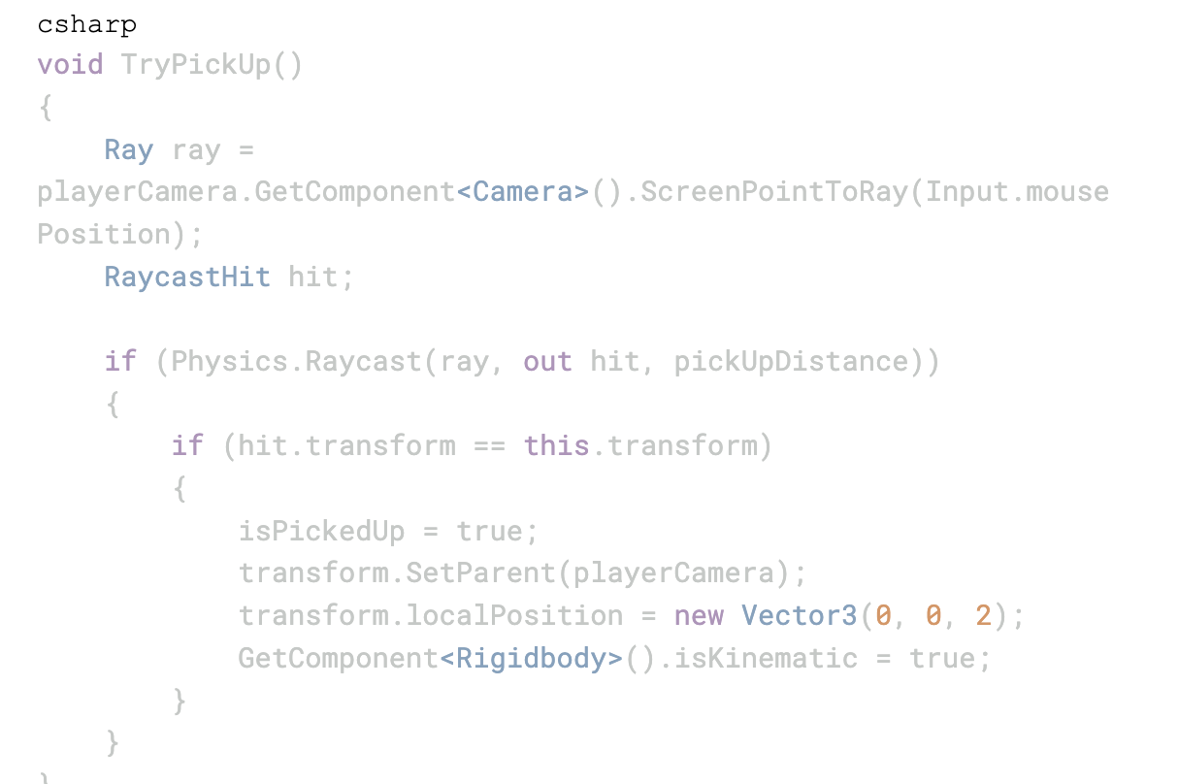

- (Simple Player Movement) retrieved from Unity Answers: Simple Player Movement Script
(http://answers.unity3d.com/answers/221574/view.html)
Last accessed 07/08/2025

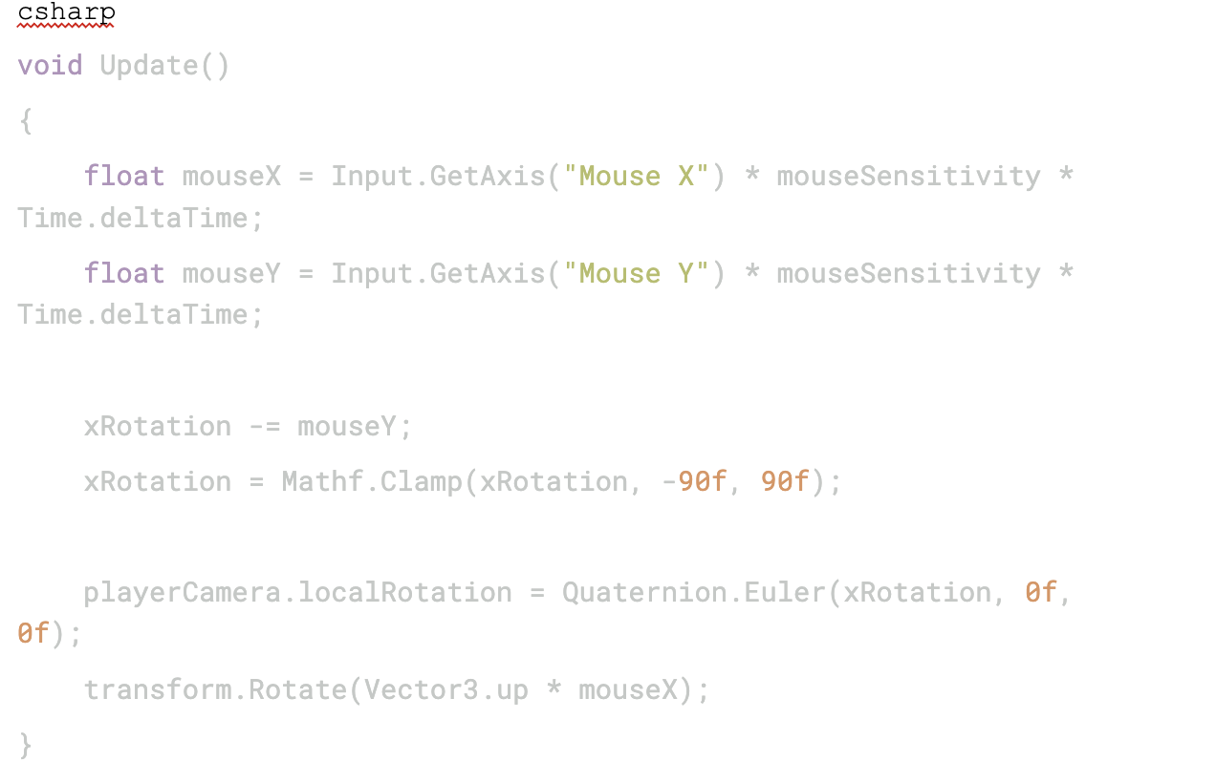

3. (Proximity Highlighter) retrieved from Unity Answers: Proximity Highlighter Script
(http://answers.unity3d.com/answers/221574/view.html)
Last accessed 17/08/2025

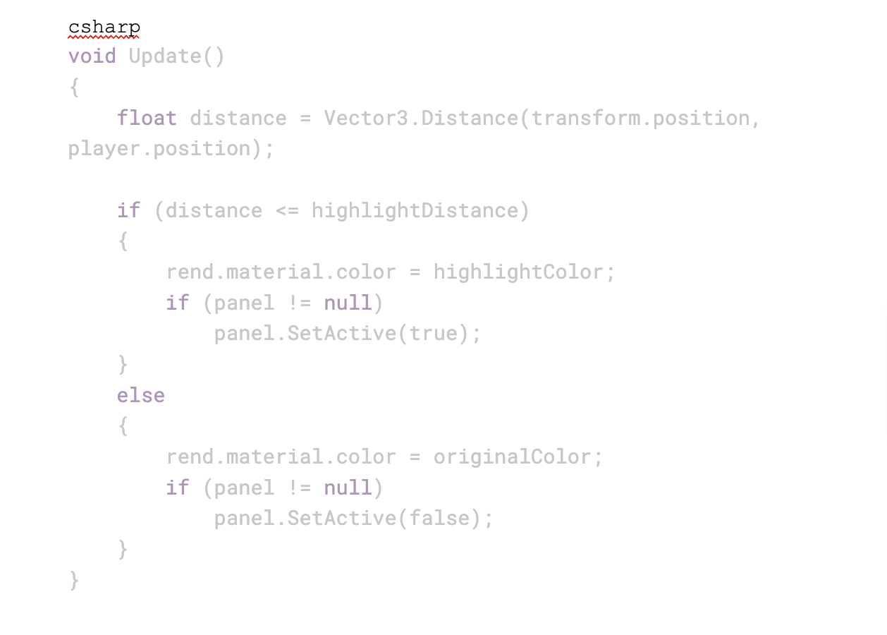

1. Interaction System Tutorial
Rytech. How to Make a Flexible Interaction System in 2 Minutes [C#] [Unity3D]. YouTube video, 4 Jan 2023.
Available at: https://www.youtube.com/watch?v=K06lVKiY-sY
Last accessed: 21/08/2025

2. Light Switch Interaction Tutorial
Speed Tutor. Switching LIGHTS ON & OFF In Unity (Interactive RAYcast Tutorial). YouTube video, 22 Jul 2021.
Available at: https://www.youtube.com/watch?v=Hm9TqF9_FjE
Last accessed: 21/08/2025

3. Distance-based Tile Colour Change Tutorial
SoomeenHahm Design (SD Info). Unity Interaction Tutorial: Change Tile Colour by Distance. YouTube video, 5 Nov 2022.
Available at: https://www.youtube.com/watch?v=qJ0-xhxZUJQ
Last accessed: 21/08/2025

